Solar Panel Splits Water to Produce Hydrogen

A research team in Belgium says its prototype panel can produce 250 liters of hydrogen gas per day

[MARIA GALLUCCI](https://spectrum.ieee.org/u/maria-gallucci)

13 MAR 2019

3 MIN READ

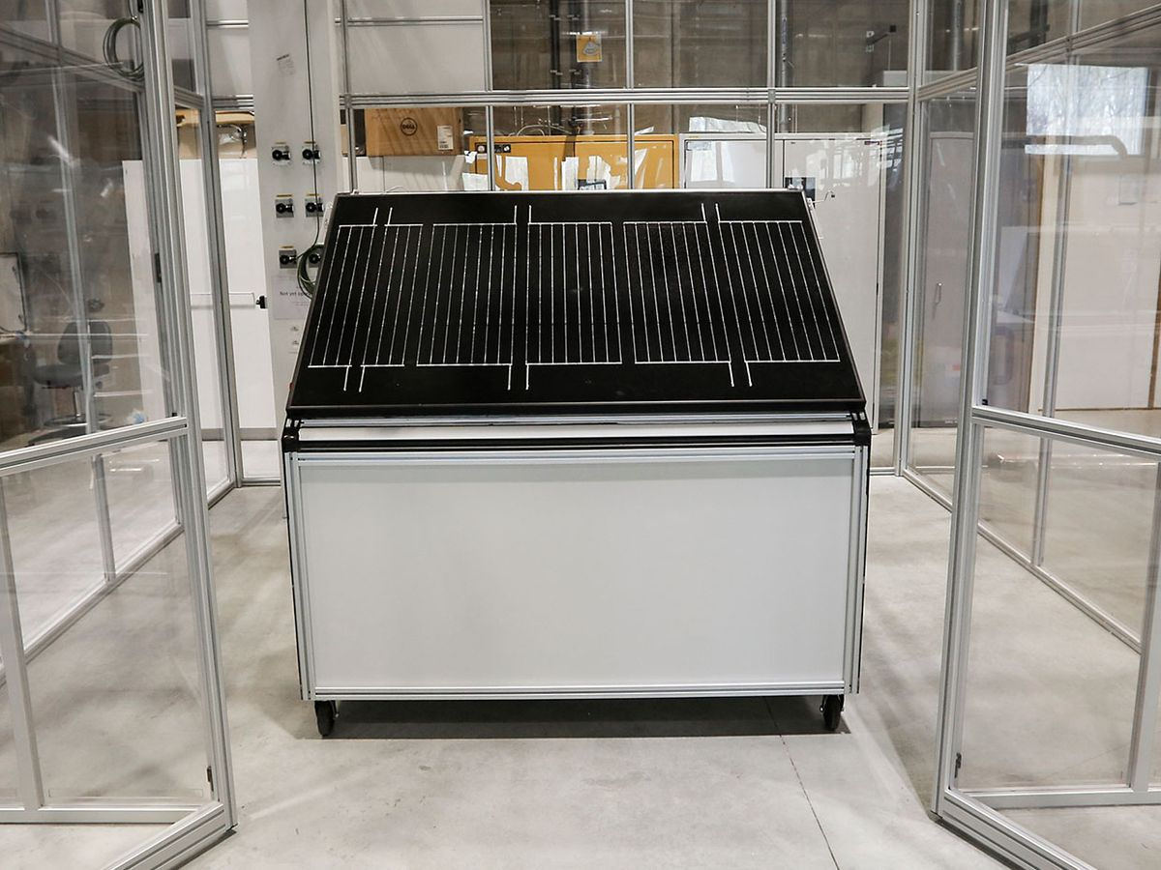

PHOTO: TOM BOSSEREZ/KU LEUVEN

[RENEWABLES](https://spectrum.ieee.org/tag/renewables)[ENVIRONMENT](https://spectrum.ieee.org/tag/environment)[SOLAR](https://spectrum.ieee.org/tag/solar)[SOLAR PANELS](https://spectrum.ieee.org/tag/solar-panels)[ELECTRICITY](https://spectrum.ieee.org/tag/electricity)[POWER](https://spectrum.ieee.org/tag/power)[HYDROGEN](https://spectrum.ieee.org/tag/hydrogen)[ENERGY](https://spectrum.ieee.org/tag/energy)

Solar panels are multiplying on rooftops and in gardens worldwide as communities clamor for renewable electricity. But engineers in Belgium say the panels could do more than keep the lights on—they could also produce hydrogen gas on site, allowing families to heat their homes without expanding their carbon footprints.

A team at [Katholieke Universiteit Leuven](https://www.kuleuven.be/english/), or KU Leuven, [says it has developed](https://nieuws.kuleuven.be/en/content/2019/belgian-scientists-crack-the-code-for-affordable-eco-friendly-hydrogen-gas) a solar panel that converts sunlight directly into hydrogen using moisture in the air. The prototype takes the water vapor and splits it into hydrogen and oxygen molecules. If it scales successfully, the technology could help address a major challenge facing the hydrogen economy.

Hydrogen, unlike fossil fuels, doesn’t produce greenhouse gas emissions or air pollution when used in fuel-cell-powered vehicles or buildings. Yet nearly all hydrogen produced today is made using an [industrial process](https://www.energy.gov/eere/fuelcells/hydrogen-production-natural-gas-reforming) that involves natural gas, and this ultimately pumps more emissions into the atmosphere.

A small but growing number of facilities are producing “green” hydrogen using electrolysis, which splits water molecules using electricity—ideally from renewable sources such as wind and solar. Other researchers, including the team in Belgium, are developing what’s called direct solar water-splitting technologies. These use chemical and biological components to split water directly on the solar panel, forgoing the need for large, expensive electrolysis plants.

“Finding a way to create hydrogen in some easier or more efficient way is maybe a Holy Grail quest,” says [Jim Fenton](https://www.fsec.ucf.edu/people/bios/Fenton.htm), who directs the [Florida Solar Energy Center](https://www.fsec.ucf.edu/en/) at the University of Central Florida.

[KU Leuven](https://www.kuleuven.be/english/) sits on a grassy campus in Flanders, the Dutch-speaking northern region of Belgium. Earlier this month, professor [Johan Martens](https://www.kuleuven.be/wieiswie/en/person/00008614) and his team at the [Centre for Surface Chemistry and Catalysis](https://www.kuleuven.be/wieiswie/en/unit/50464356) announced their prototype could produce 250 liters of hydrogen per day on average over a full year, which they claim is a world record. A family living in a well-insulated Belgian house could use about 20 of these panels to meet their power and heating needs during an entire year, they predict.

The solar panel measures 1.65 meters long—roughly the height of a kitchen refrigerator, or this reporter—and has a rated power output of about 210 watts. The system can convert 15 percent of the solar energy it receives into hydrogen, the team says. That’s a significant leap from 0.1 percent efficiency they first achieved 10 years ago. (Separately, international researchers last year [said they achieved](https://pubs.acs.org/doi/10.1021/acsenergylett.8b00920) 19 percent efficiency in producing hydrogen from direct solar water splitting.)

**“The most difficult part is getting the water out of the air.”**

However, Martens’s lab was tight-lipped about its technology. [Tom Bosserez](https://www.kuleuven.be/wieiswie/en/person/91635), a post-doctoral researcher, declined to disclose any specifics, citing intellectual property concerns. He says only that the lab specializes in “catalysts, membranes, and adsorbents.”

“Using our expertise in this area, we were able to develop a system that is very efficient in taking water from the air and splitting it into hydrogen by using solar energy,” Bosserez wrote in an email. Asked about some of the engineering challenges they faced during a decade of development, he says, “The most difficult part is getting the water out of the air.”

Academic papers offer scattered clues about the technology, though Bosserez says their research “goes beyond what we publish.” In recent years, the engineers have studied the efficacy of a variety of materials, including porous, multi-junction [silicon solar cells](https://www.sciencedirect.com/science/article/pii/S0927024818301521?via%3Dihub) with “micrometer-scale pore dimensions”; [thin-film catalysts](https://pubs.rsc.org/en/content/articlelanding/2016/ra/c6ra19188f#!divAbstract) made from manganese (III) oxide; and a poly (vinyl alcohol) [anion exchange membrane](https://www.sciencedirect.com/science/article/pii/S0920586118308447?via%3Dihub) involving a potassium hydroxide solution and nickel-based catalysts.

Martens says generally that his team is using “cheap raw materials” in lieu of precious metals and other expensive components. “We wanted to design something sustainable that is affordable and can be used practically anywhere,” [he told VRT](https://nieuws.kuleuven.be/en/content/2019/belgian-scientists-crack-the-code-for-affordable-eco-friendly-hydrogen-gas), a public broadcasting network in Belgium.

Researchers plan to field test their prototype at a house in the rural town of Oud-Heverlee. Hydrogen would be stored in a small, underground pressure vessel during the summer months, then pumped throughout the house during the winter. If all goes according to plan, Martens says the team could install 20 panels at the house, or build a larger neighborhood system to allow other families to use the “green” hydrogen.

Fenton, of the Florida Solar Energy Center, says it’s far too early to determine whether or when hydrogen-producing solar panels could become economically viable. The technology is still in the very early development stage, and—particularly in the United States—existing heating fuels such as natural gas are relatively cheap. However, as countries work to address [climate change](https://spectrum.ieee.org/tag/climate-change), and as more communities install local renewable energy infrastructure like rooftop solar, he sees a potential role for these hydrogen systems

# **Out of thin air: new solar-powered invention creates hydrogen fuel from the atmosphere**

This article is more than 1 year old

**Researchers say their prototype produces hydrogen with greater than 99% purity and works in air as dry as 4% relative humidity**

* [**Follow our Australia news live blog for the latest updates**](https://www.theguardian.com/australia-news/live/2022/sep/07/australian-politics-live-medicines-housing-cost-of-living-rba-interest-rates-anthony-albanese-mark-butler-childcare-strikes)
* **Get our**[**free news app**](https://www.theguardian.com/technology/ng-interactive/2018/may/15/the-guardian-app?CMP=cvau_sfl)**,**[**morning email briefing**](https://www.theguardian.com/world/guardian-australia-morning-mail/2014/jun/24/-sp-guardian-australias-morning-mail-subscribe-by-email?CMP=cvau_sfl)**or**[**daily news podcast**](https://www.theguardian.com/australia-news/series/full-story?CMP=cvau_sfl)

[**Donna Lu**](https://www.theguardian.com/profile/donna-lu)

[**@donnadlu**](https://www.twitter.com/donnadlu)

Tue 6 Sep 2022 18.30 BST

Researchers have created a solar-powered device that produces [hydrogen fuel](https://www.theguardian.com/environment/hydrogen-power) directly from moisture in the air.

According to its inventors, the prototype produces hydrogen with greater than 99% purity and can work in air that is as dry as 4% relative humidity. The device would allow hydrogen to be produced without carbon emissions even in regions where water on land is scarce, they say.

Hydrogen is a zero-carbon fuel that yields only water as a byproduct when used in fuel cells. However, pure hydrogen is not abundant in nature and producing it requires energy input. Large-scale production commonly involves fossil fuels that generate [carbon emissions](https://www.theguardian.com/commentisfree/2021/may/06/difference-real-climate-policy-greenwashing-emissions).

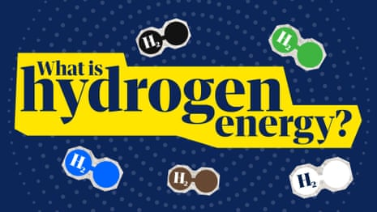

**00:03:28**

What is hydrogen energy? And what's the difference between blue and green hydrogen? | News glossary

The study’s lead author and a senior lecturer in chemical engineering at the University of Melbourne, Dr Gang Kevin Li, said the hydrogen-producing device could be powered by solar or wind energy.

A prototype produced hydrogen for more than 12 consecutive days in a monitored trial. “[For] one of them, we left it to run by itself for eight months,” Li said.

* [Sign up to receive an email with the top stories from Guardian Australia every morning](https://www.theguardian.com/world/guardian-australia-morning-mail/2014/jun/24/-sp-guardian-australias-morning-mail-subscribe-by-email?CMP=copyembed)

The device is comprised of spongy material with a hygroscopic liquid – fluid that absorbs moisture from the air, similar in function to silica gel sachets. The absorbed water molecules are then split at electrodes into hydrogen and oxygen gasses, a process known as electrolysis.

“Hydrogen is the ultimate clean energy … as long as you have renewable sources of energy to electrolyse the water,” Li said.

[skip past newsletter promotion](https://www.theguardian.com/environment/2022/sep/07/out-of-thin-air-new-solar-powered-invention-creates-hydrogen-fuel-from-the-atmosphere#EmailSignup-skip-link-9)

**Sign up to Morning Mail**

**Free daily newsletter**

Our Australian morning briefing breaks down the key stories of the day, telling you what’s happening and why it matters

**Privacy Notice:**Newsletters may contain info about charities, online ads, and content funded by outside parties. For more information see our [Privacy Policy](https://www.theguardian.com/help/privacy-policy). We use Google reCaptcha to protect our website and the Google [Privacy Policy](https://policies.google.com/privacy) and [Terms of Service](https://policies.google.com/terms) apply.

after newsletter promotion

[[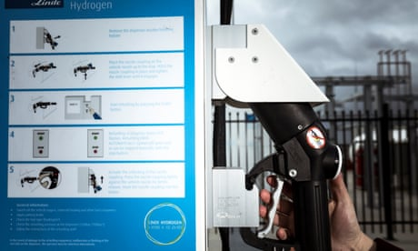](https://www.theguardian.com/environment/2022/jul/18/hydrogen-fuel-stations-to-be-built-between-sydney-and-melbourne-under-20m-plan)](https://www.theguardian.com/environment/2022/jul/18/hydrogen-fuel-stations-to-be-built-between-sydney-and-melbourne-under-20m-plan)

[Hydrogen fuel stations to be built between Sydney and Melbourne under $20m plan](https://www.theguardian.com/environment/2022/jul/18/hydrogen-fuel-stations-to-be-built-between-sydney-and-melbourne-under-20m-plan)

[Read more](https://www.theguardian.com/environment/2022/jul/18/hydrogen-fuel-stations-to-be-built-between-sydney-and-melbourne-under-20m-plan)

The device is estimated to produce up to 93 litres of hydrogen a square metre an hour. “If you have 10 sq metres of this unit, you can power a whole house … to replace your consumption of natural gas at home for [cooking and heating](https://www.theguardian.com/science/2020/mar/21/is-hydrogen-the-solution-to-net-zero-home-heating),” Li said.

The prototypes are still only small in size, and the team has plans to create 1 sq metre and 10 sq metres units in the coming year.

The researchers envisage the device could be a useful tool in regions where liquid water is not readily available for producing hydrogen. “Large parts of the world have water scarcity problems,” Li said. “When you have lots of renewable energy – wind or solar – you [often] don’t have much fresh water for this type of hydrogen production.”

Dr Kim Beasy of Swinburne University’s Victorian Hydrogen Hub, who was not involved in the research, said hydrogen fuel, while important, was not a silver bullet for reaching net zero. “We’re coming to understand that hydrogen is going to be one piece of the puzzle,” she said.

[[](https://www.theguardian.com/world/2022/jun/30/queensland-airline-skytrans-unveils-plans-for-australias-first-hydrogen-fuelled-plane)](https://www.theguardian.com/world/2022/jun/30/queensland-airline-skytrans-unveils-plans-for-australias-first-hydrogen-fuelled-plane)

[Queensland airline Skytrans unveils plans for Australia’s first hydrogen-fuelled plane](https://www.theguardian.com/world/2022/jun/30/queensland-airline-skytrans-unveils-plans-for-australias-first-hydrogen-fuelled-plane)

[Read more](https://www.theguardian.com/world/2022/jun/30/queensland-airline-skytrans-unveils-plans-for-australias-first-hydrogen-fuelled-plane)

“It’s going to provide us with direction out of some pretty hard-to-mitigate industries such as transport. We have no alternative to diesel at the moment … hydrogen is a really good option.”

The required economies of scale were “probably not going to be reached with clean hydrogen straight away”, Beasy said, citing the expensive price of conventional hydrogen electrolysers. “What we really need is more government support and subsidies in bringing down the cost of getting this technology on the ground.”

The study was published in the journal [Nature Communications](https://doi.org/10.1038/s41467-022-32652-y).

 This article was amended on 14 September 2022 to make clear that hydrogen produces only water as a byproduct when used in fuel cells. When burned in air it also produces nitrogen oxides.

**… there is a good reason why people choose not to support the Guardian.**

Not everyone can afford to pay for the news right now. That’s why we choose to keep our journalism open for everyone to read. If this is you, please continue to read for free.

But if you can, then here are **three** good reasons to make the choice to support us today from Tunisia.

**1.** Our quality, investigative journalism is a scrutinising force at a time when the rich and powerful are getting away with more and more.

**2.** We are independent and have no billionaire owner controlling what we do, so your money directly powers our reporting.

**3.** It doesn’t cost much, and takes less time than it took to read this message.

Choose to power the Guardian’s journalism for years to come, whether with a small sum or a larger one.**If you can, please support us on a monthly basis from just $2. It takes less than a minute to set up, and you can rest assured that you’re making a big impact every single month in support of open, independent journalism. Thank you**